REPORT

FEATURE SELECTION

SHISHIR DUBEY

ID 0291

MSc BIGDATA

EXERCISE 1

To generate a dataset named Toys with n=50 observations and p=20 variables which satisfies the following conditions,
Y ∈ {− 1 , 1 } following a uniform distribution
With probability 0.7,
x i ∼ yN(i, 1 ), i = 1 , 2 , 3
x i ∼ yN( 0 , 1 ), i = 4 , 5 , 6
else
x i ∼ yN( 0 , 1 ), i = 1 , 2 , 3
x i ∼ yN(i − 3 , 1 ), i = 4 , 5 , 6
For the other variables :
x i ∼ N( 0 , 20 ), i = 7 ,. . . , p
2) To perform T-Test on the generated Toys dataset and to rank each variable in the dataset based on the p-value.
3) To rank each variable in the dataset based on the Fisher Discriminative Score.

RCODE

#################-----------------EXERCISE 1-----------------####################

y=ifelse(runif(50,0,1)<0.5,-1,1)
choice=runif(50)<0.7
############----------------DATASET FOR THE TOYS--------##############

x1=choice*y*rnorm(50,1,1) + (1-choice)*y*rnorm(50,0,1)
x2=choice*y*rnorm(50,2,1) + (1-choice)*y*rnorm(50,0,1)
x3=choice*y*rnorm(50,3,1) + (1-choice)*y*rnorm(50,0,1)
x4=choice*y*rnorm(50,0,1) + (1-choice)*y*rnorm(50,1,1)
x5=choice*y*rnorm(50,0,1) + (1-choice)*y*rnorm(50,2,1)
x6=choice*y*rnorm(50,0,1) + (1-choice)*y*rnorm(50,3,1)
x7=rnorm(50,0,20)
x8=rnorm(50,0,20)
x9=rnorm(50,0,20)
x10=rnorm(50,0,20)
x11=rnorm(50,0,20)
x12=rnorm(50,0,20)
x13=rnorm(50,0,20)
x14=rnorm(50,0,20)
x15=rnorm(50,0,20)
x16=rnorm(50,0,20)
x17=rnorm(50,0,20)
x18=rnorm(50,0,20)
x19=rnorm(50,0,20)
x20=rnorm(50,0,20)

#REPRESENTING DATASET IN A MATRIX
m=data.frame(y,x1,x2,x3,x4,x5,x6,x7,x8,x9,x10,x11,x12,x13,x14,x15,x16,x17,x18,x19,x20)
pairs(m[,2:7],col=5+y)

mpos <- subset(m,m$y==1) #SPLITTED MATRIX VALUES CONTAINING Y=1
mneg <- subset(m,m$y==-1) #SPLITTED MATRIX VALUES CONTAINING Y=-1
mtest <- rep(0:20)

##-----PERFORMING T-TEST

for(i in 2:21)
{
mtest[i-1] <- t.test(mpos[,i],mneg[,i])$p.value
}

mtest
order(mtest)

##----CALCULATING FISHER DISCRIMINATIVE SCORE
FDS← rep(0:20)
for(i in 2:21){
FDS[i]<- abs(mean(mpos[,i]-mean(mneg[,i])))/(sd(mpos[,i])-sd(mneg[,i]))
}
order(FDS,decreasing = TRUE)

OUTPUT:-
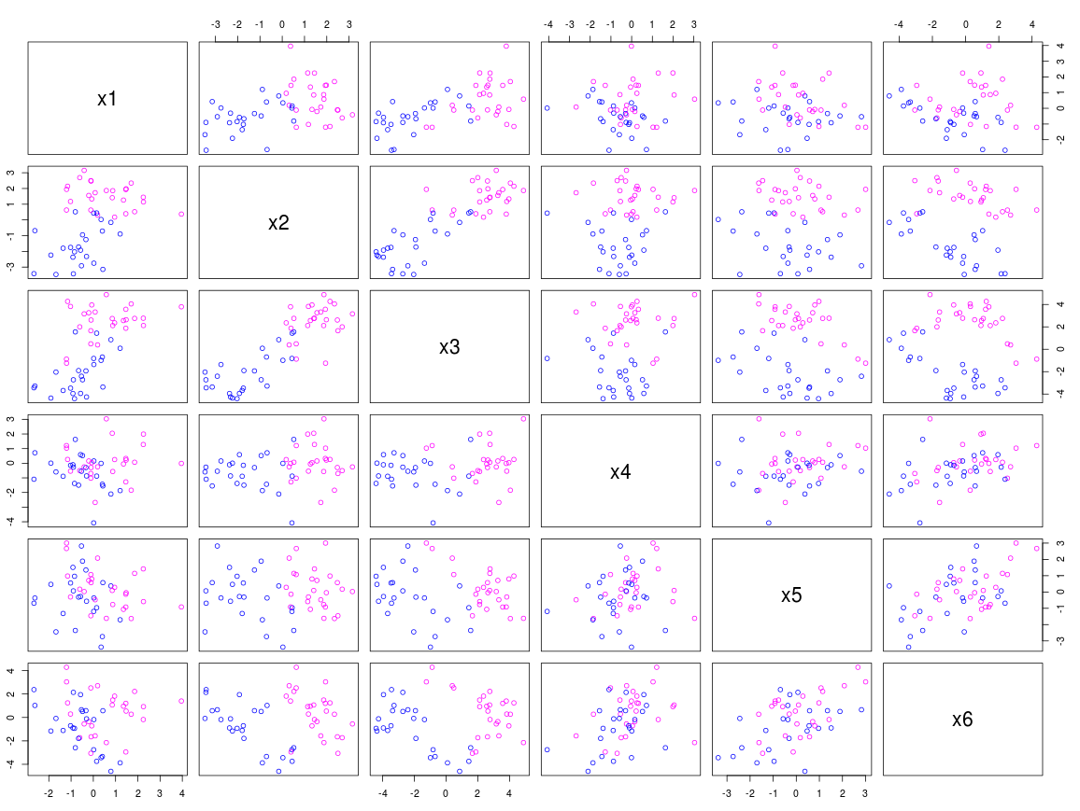
RANKINGS

##RANKING ON THE BASIS OF T-TEST ::--

[1] 3 2 1 5 6 11 4 20 13 10 19 9 15 17 7 8 12 16 14 18 21

##RANKING ON THE BASIS OF FISHER'S TEST :--

[1] 1 5 2 3 4

CONCLUSION

1) After seeing the scatter plot we can easily state that data is linearly separable with higher probability decreasing with Sample Size.

2) The Results obtained from the T-TEST and FISHER'S TEST defines that first 6 variables are ranked at the top and these testing defines the 70 % probabibility for first 6 variable and 30 % for the other Variables.

EXERCISE 2

AIM :
1) To generate a dataset named Null Model with n=50 observations and p=10 variables which satisfies the following conditions,

x i ∼ N( 0 , 1 ), i = 1 ,. . . , p

2) To generate a dataset named Corr Model with n=50 observations and p=5 variables which satisfies the following conditions,

x i ∼ N( 0 , 1 ), i = 1 ,. . . , p

Correlation between x1 & x2 should be 0.9.

3) To perform T-Test & Fisher Test on the generated Null Model & Corr Model dataset and to rank each variable in the dataset based on the p-value and Fisher Discriminative Score.

4) To perform Recursive Partitioning on the Toys, Null Model & Corr Model datasets and generate trees and show the variable importance.

RCODE

#######################------EXERCISE 2-------##########################

## RPART
##DATASET FOR TOYS

library(rpart)
rprt_out <- rpart(y~.,n_mod)
X11()
plot(rprt_out)
text(rprt_out)
sel_var<- rprt_out$variable.importance
sel_var
summary(rprt_out)

## VARIANCE IMPORTANCE :
# V7 V8 V10 V3 V2 V1 V4
# 36 27 20 7 6 4 1

##### DATASET FOR NULL MODEL

n_mod<-as.data.frame(matrix(0, ncol = 10, nrow = 50))
y<-ifelse(runif(50,0,1)<0.5,1,-1)

for (i in 1:10){
n_mod[,i]<-rnorm(50,0,1)
}

## T-TEST

t_array1 <- rep(0,10)
for(i in 1:10) {
t_array1[i]<- (t.test(n_mod[y==1,i],n_mod[y==-1,i])$p.value)
}

order(t_array1)
## RESULT : 2 5 7 10 4 8 9 6 3 1

## FISHER DISCRIMINATIVE SCORE
FDS <- rep(0,10)
for(i in 1:10) {
FDS[i]<- abs((mean(n_mod[y==1,i])-mean(n_mod[y==-1,i]))/(sd(n_mod[y==1,i])- sd(n_mod[y==-1,i])))
}

order(FDS,decreasing = TRUE)

## RESULT : 7 8 5 2 10 4 1 6 3 9

##### CORRELATION MODEL DATASET

c_mod<-as.data.frame(matrix(0, ncol = 5, nrow = 50))
y<-ifelse(runif(50,0,1)<0.5,1,-1)

t1_mod <- mvrnorm(50, mu = c(0,0), Sigma = matrix(c(1,0.90,0.90,1), ncol = 2),empirical = TRUE)
View(t1_mod)

t2_mod<-as.data.frame(matrix(0, ncol = 3, nrow = 50))
for (j in 1:3){
t2_mod[,j]<-rnorm(50,0,1)
}
View(t2_mod)
c_mod<-cbind(t1_mod,t2_mod)

View(c_mod)
cor(c_mod[,1],c_mod[,2])

## T-TEST
t_array2 <- rep(0,5)
for(i in 1:5) {
t_array2[i]<- (t.test(c_mod[y==1,i],c_mod[y==-1,i])$p.value)
}

order(t_array2)
## RESULT : 5 3 2 4 1

## FISHER DISCRIMINATIVE SCORE
FDS <- rep(0,5)
for(i in 1:5) {
FDS[i]<- abs((mean(c_mod[y==1,i])-mean(c_mod[y==-1,i]))/(sd(c_mod[y==1,i])-sd(c_mod[y==-1,i])))
}

order(FDS,decreasing = TRUE)
## RESULT : 5 3 2 4 1

## RPART

library(rpart)
rprt_out <- rpart(y~.,corr_model)
X11()
plot(rprt_out)
text(rprt_out)
sel_var<- rprt_out$variable.importance
sel_var
summary(rprt_out)

## VARIANCE IMPORTANCE :
# 2 V3 1 V1 V2
# 39 25 20 13 3

OUTPUT:-

=> Ranking of all the variables in the Null Model dataset based on the p-value generated by the T-Test :
[1] 2 5 7 10 4 8 9 6 3 1

=> Ranking of all the variables in the Null Model dataset based on the Fisher Discriminative Score :

[1] 7 8 5 2 10 4 1 6 3 9

=> Ranking of all the variables in the Corr Model dataset based on the p-value generated by the T-Test :

[1] 5 3 2 4 1

=> Ranking of all the variables in the Corr Model dataset based on the Fisher Discriminative Score :

[1] 5 3 2 4 1

=> Tree and Variable Importance Observed using Recursive Partitioning on the Toys dataset :

VARIANCE IMPORTANCE :
V7 V8 V10 V3 V2 V1 V4
36 27 20 7 6 4 1

OUTPUT:-

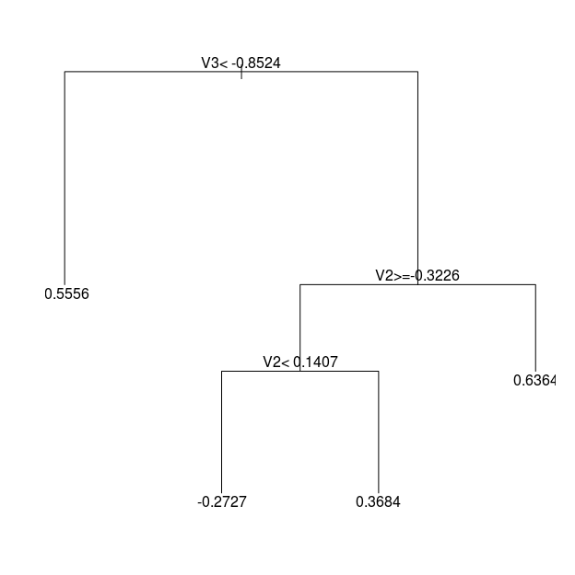

=> Tree and Variable Importance Observed using Recursive Partitioning on the Null Model dataset :

VARIANCE IMPORTANCE :
V7 V8 V10 V3 V2 V1 V4
36 27 20 7 6 4 1

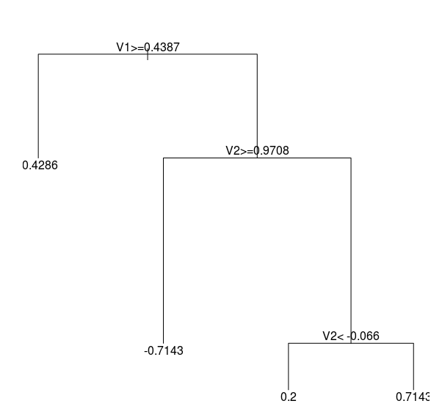

=> Tree and Variable Importance Observed using Recursive Partitioning on the Corr Model dataset :

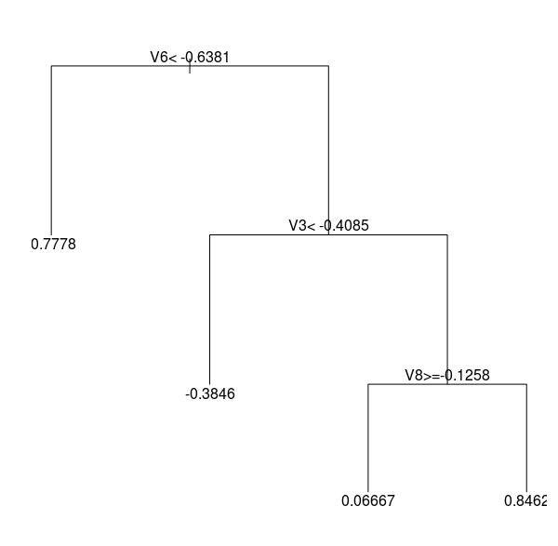

CONCLUSION

- we can conclude that mostly the explanatory variables with high probability are given higher variable importance for the toys dataset looking at the tree and the summary of the rpart function

- we can conclude that the correlated explanatory variables are given higher variable importance as compared to other variables and as the two variables have a very high correlation of 0.9 so they are given equal importance for the Corr Model dataset looking at the tree and the summary of the rpart function

